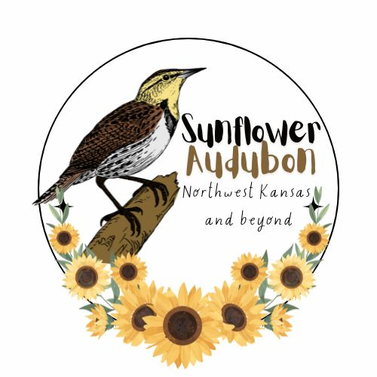Sunflower Chapter of Audubon

Membership Form

If you are a member of the National Audubon Society, you are automatically a member of our local chapter, but the Sunflower Chapter receives less than $3 per national member to support local efforts that include our newsletter, educational programs and participation in community activities such as guided bird walks and field trips.

Please complete this form and send it with your check for $20 to:

Sunflower, a Chapter of Audubon, P.O. Box 362, Hays, KS 67601. Thank you!

**Individual/Family: $20**

Student: $15

Optional Additional Contribution: ____$20 _____$50 _____$100 _____$Other

Name (please print):

___________________________________________________________________

Address:

___________________________________________________________________

City, State, Zip:

___________________________________________________________________

Phone:

___________________________________________________________________

Email:

____________________________________________________________________

If you would like to receive your bi-annual newsletter by email: circle **YES**

by USPS: circle **YES**